**INITIAL FINDINGS:**

1. Number of loans sanctioned for each sector.

Agriculture 180302

Food 136657

Retail 124494

Services 45140

Personal Use 36385

Housing 33731

Clothing 32742

Education 31013

Transportation 15518

Arts 12060

Health 9223

Construction 6268

Manufacturing 6208

Entertainment 830

Wholesale 634

1. Amount Sanctioned for each sector.

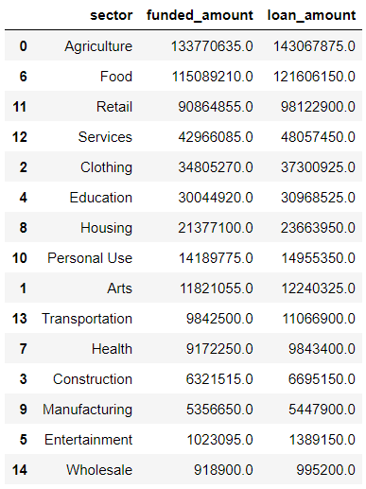

1. Female borrowers are approximately three times as that of the male borrowers.
2. The discrepancy between the funded_amount and loan_amount is negligible.

The rest of the findings are present in the notebook along with visualizations.